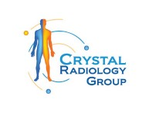The Importance of Medical Imaging at Crystal Radiology. (02) 8315 8292

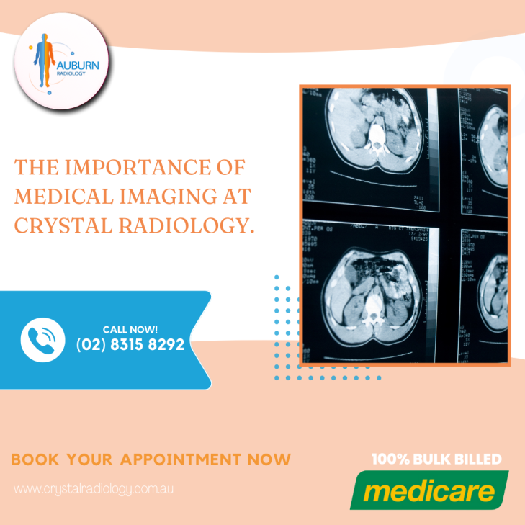Medical imaging is a cornerstone of modern healthcare, enabling physicians to diagnose, monitor, and treat a wide array of medical conditions with precision. At Crystal Radiology, we pride ourselves on providing advanced [medical imaging](https://crystalradiology.com.au/x-ray/) services to help patients and practitioners achieve the best possible outcomes. By merging cutting-edge technology with compassionate care, we aim to highlight the immense value of medical imaging in today’s healthcare landscape.

# Transforming Diagnosis and Treatment

Medical imaging is a powerful diagnostic tool that bridges the gap between symptoms and accurate diagnosis. From X-rays to CT scans, and ultrasounds to Dental Imaging, these technologies allow healthcare providers to visualize internal structures in ways that would be impossible with a physical examination alone.

At Crystal Radiology, we recognize that a proper diagnosis forms the foundation for effective treatment. Medical imaging helps:

* **Confirm Diagnoses:** While a physician’s knowledge and expertise are critical, imaging offers visual confirmation of suspected conditions, such as [fractures, tumors](https://crystalradiology.com.au/x-ray/), or infections.
* Guide Treatment Plans: Imaging results inform personalized treatment strategies, ensuring patients receive the most suitable care.
* **Track Progress:** For chronic conditions or ongoing treatment, imaging allows physicians to monitor how a condition evolves or how well a treatment is working.
* For example, CT scans provide detailed cross-sectional images of the body, making them invaluable for identifying abnormalities and planning surgeries. At Crystal Radiology, our state-of-the-art equipment ensures clear, high-resolution images to aid in swift and accurate decision-making.

# A Preventative Healthcare Tool

Prevention is better than cure, and medical imaging plays a pivotal role in early detection. Routine imaging evaluations, such as mammograms, have significantly contributed to reducing mortality rates in conditions like breast cancer.

Since 1990, the increased use of mammograms has been linked to a [30% decline](https://crystalradiology.com.au/x-ray/) in breast cancer-related deaths. At Crystal Radiology, we emphasize the importance of preventative imaging services, empowering patients to take proactive steps toward their health. By detecting abnormalities early, we help patients avoid more invasive treatments and improve their long-term prognosis.

# Supporting Surgeons with Precision

Surgical success often depends on accurate pre-operative planning and intraoperative guidance, both of which are made possible through medical imaging.

**For instance:**

* **Endoscopic Sinus Surgery:** Before addressing the intricate sinus network, surgeons rely on CT scans to map out the area. The detailed 3D cross-sectional images provide a clear understanding of the anatomy, minimizing risks during the procedure.
* **Guided Surgery:** Imaging technologies like real-time [CT scans](https://crystalradiology.com.au/x-ray/) or fluoroscopy assist surgeons during procedures, enhancing precision and safety.

At Crystal Radiology, we collaborate closely with surgeons to provide the imaging insights they need for successful outcomes.

# Enhancing Quality of Life

Medical imaging doesn’t just save lives; it enhances them. Whether it’s identifying the cause of chronic pain, detecting the early stages of a disease, or providing a clearer picture for a complex surgery, imaging improves the overall quality of care for patients.

For individuals dealing with chronic conditions, imaging provides invaluable feedback, allowing healthcare providers to fine-tune treatments and improve outcomes. At [Crystal Radiology](https://crystalradiology.com.au/x-ray/), we understand the importance of compassionate care, ensuring patients feel supported throughout their imaging journey.

# Innovations in Medical Imaging

The future of medical imaging is bright, with ongoing advancements promising even greater benefits. Emerging technologies such as AI-powered imaging and more portable devices are set to revolutionize healthcare delivery.

At [Crystal Radiology](https://crystalradiology.com.au/), we stay at the forefront of these advancements, ensuring our patients and referring physicians have access to the latest innovations. With improved resolution, faster processing times, and more precise techniques, we are prepared to continue meeting the ever-evolving needs of our community.

# Conclusion

Medical imaging is an indispensable part of modern healthcare, aiding in diagnostics, treatment planning, and preventative care. At Crystal Radiology, we are dedicated to providing exceptional imaging services that improve outcomes and enhance lives.

Whether you need an X-ray, ultrasound, CT scan, or another imaging service, trust [Crystal Radiology](https://crystalradiology.com.au/appointment) to deliver accurate results with care and precision. By choosing us, you’re not just receiving a scan—you’re gaining a partner in your health journey.

# Why Choose Crystal Radiology?

We are local and a Privately-owned medical Clinics that offers the highest quality medical and Imaging Services in the [Crystal region](https://crystalradiology.com.au/appointment). We are the leaders in Bulk Billing with the real benefit of no ‘Out of Pocket’ expenses for you.

# Your Next Step

Please ensure that you have your Medicare card and referral with you and pop into our location for your consultation. If you have any questions at all, please feel free to contact us on [(02) 8315 8292](https://crystalradiology.com.au/appointment) as we are here to help.